Project Design Phase
Solution Architecture

Date | 25 February 2026
Team ID | LTVIP2026TMIDS81684
Project Name | Calculating Family Expenses using ServiceNow
Maximum Marks | 4 Marks

Solution Architecture:
Solution architecture is a complex process – with many sub-processes – that bridges the gap between business problems and technology solutions. Its goals are to:
- Find the best tech solution to solve existing business problems.
- Describe the structure, characteristics, behavior, and other aspects of the software to project stakeholders.
- Define features, development phases, and solution requirements.
- Provide specifications according to which the solution is defined, managed, and delivered.
The proposed solution architecture for the “Calculating Family Expenses using ServiceNow” system is based on the ServiceNow cloud platform. The architecture includes a user interface layer where family members interact with forms and dashboards, an application logic layer that handles workflows, business rules, and automation, and a data layer where expense records are stored securely in ServiceNow tables. The system ensures centralized data management, automatic calculations, and secure role-based access control. The architecture also supports scalability and integration capabilities for future enhancements.

Example - Solution Architecture Diagram:


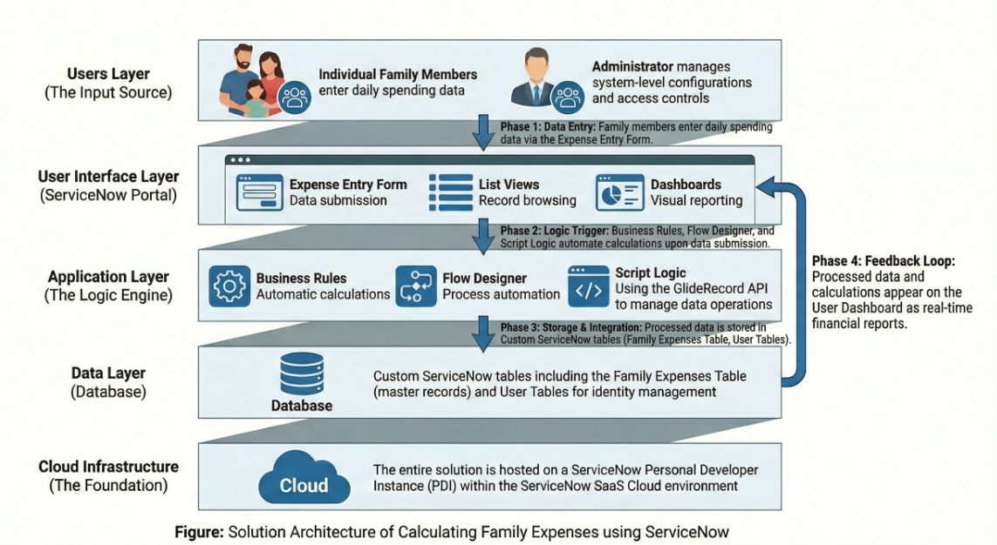
Figure 1: Architecture and data flow of the voice patient diary sample application
Reference: https://aws.amazon.com/blogs/industries/voice-applications-in-clinical-research-powered-by-ai-on-aws-part-1-architecture-and-design-considerations/

